Url Slug Suggestion - https://rootcabs.com/taxi-in-trichy
Primary Keyword
taxi service in trichy
trichy cab service
trichy cabs
Secondary Keyword
one way drop taxi trichy
one way taxi trichy
call taxi trichy
taxi in trichy
one drop taxi trichy
drop taxi chennai to trichy
trichy to chennai taxi
cab from trichy to chennai
drop taxi trichy to chennai
one way drop taxi trichy to chennai
cabs in trichy
trichy one way taxi
chennai to trichy drop taxi
cab booking trichy
chennai to trichy cab
drop taxi in trichy
trichy airport taxi
call taxi in trichy
best taxi service in trichy
best taxi trichy
best track call taxi trichy tariff
call taxi service in trichy
Page Layout

H1 - Taxi Service in Trichy - Rock Fort City & Srirangam Temple Rides

H2 - Fare Calculator
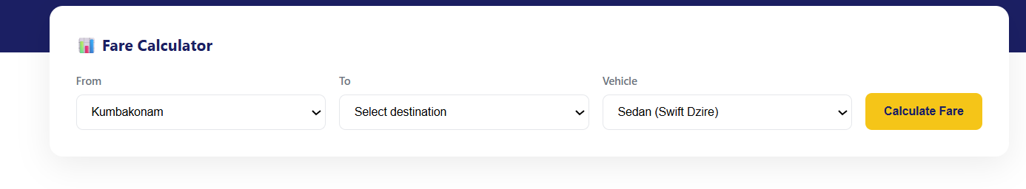

H2 - Services Available in Trichy
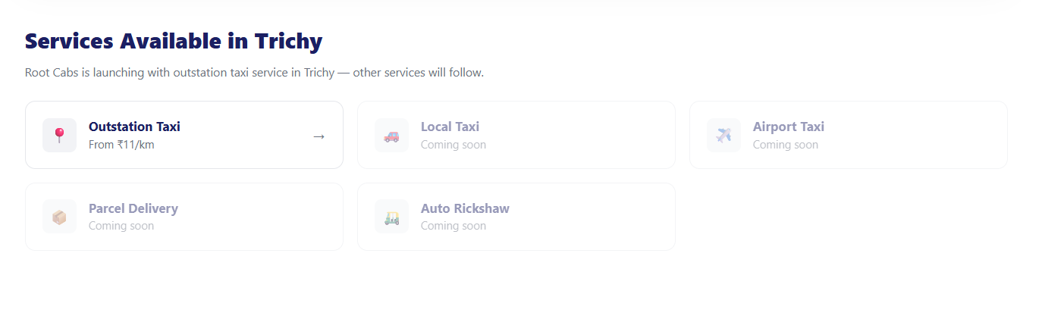

H2 - Popular Routes from Trichy
Write two lines of content below like short intro for this header
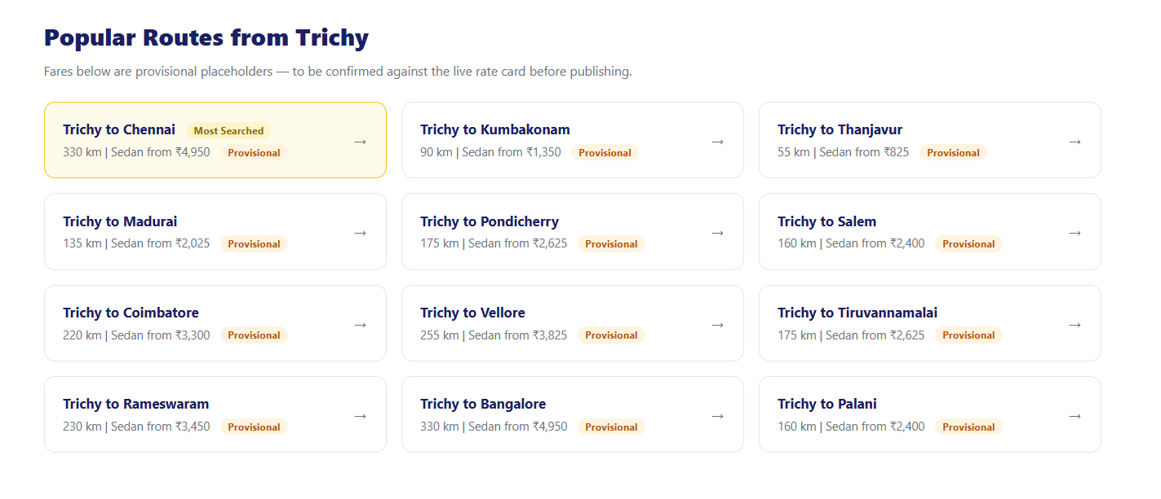

H2 - Popular Pickup Spots In Trichy
Write two lines of content below like short intro for this header

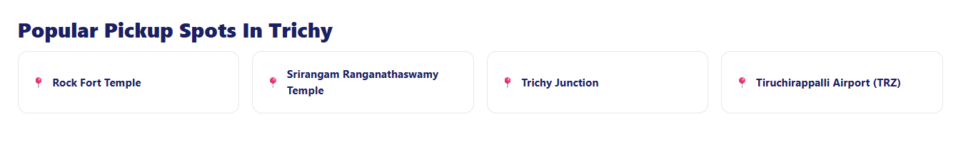

H2 - Rock Fort & Srirangam — Trichy's Landmark Temples
H3 - Rock Fort Temple (Ucchi Pillayar Kovil)
H3 -Ranganathaswamy Temple, Srirangam
H3 -Jambukeswarar Temple, Thiruvanaikaval
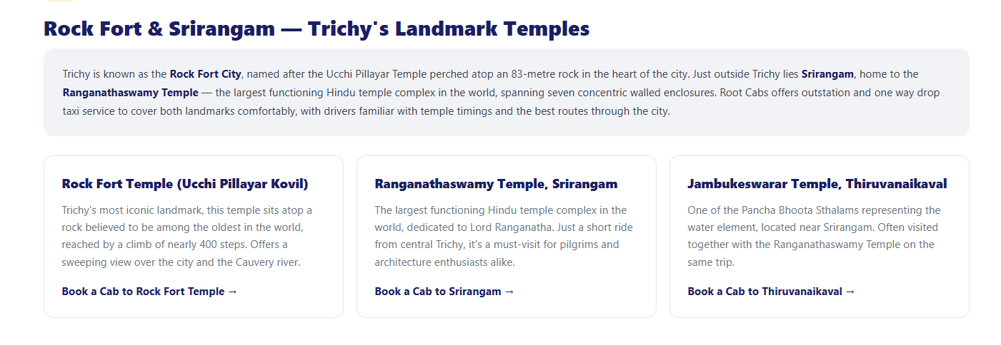

H2 - Customer Reviews in Trichy
Write three customer review for this section



H2 - Why Choose Root Cabs in Trichy?
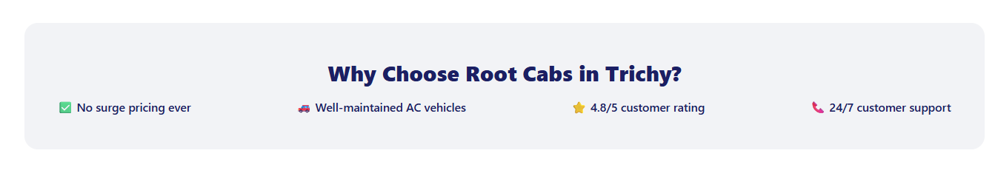
H2 - Driving With Root Cabs in Trichy
H3 - Become a Driver Partner
H3 - Need an Acting Driver?


Acting driver section added - Purpose interlinking to the acting driver page.


H2 - Frequently Asked Questions
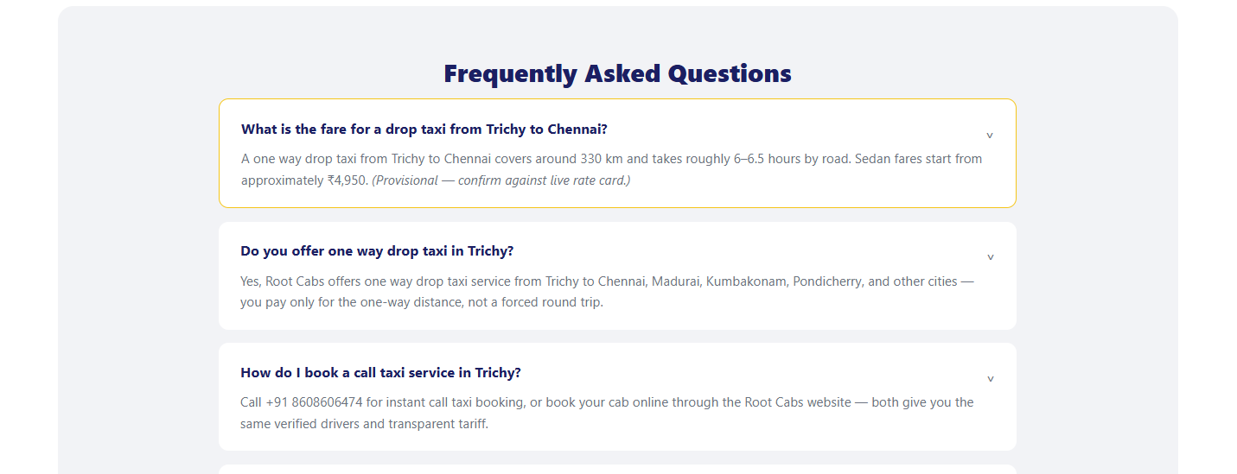
Which taxi is cheaper in Trichy?
Are taxis in Trichy available 24/7?
How do I book a taxi in Trichy?
What vehicle types are available for outstation trips from Trichy?
Is Root Cabs available in Trichy as an app?

